**----------------------------------------------------------------------------------------------------------------------------------------**

**Sikuli installation**

1. Create **Softwares** folder in **C** drive.
2. Copy **sikuli-install** folder in to C drive
3. Double click on **runSetup** - click on Yes/yes/ until you get Success message

**----------------------------------------------------------------------------------------------------------------------------------------**

**System variables set up for Sikuli**

1. **CLASSPATH**--->C:\Softwares\sikuli-install\sikuli-ide.jar;C:\Softwares\sikuli-install\sikuli-script.jar;
2. **Path**-->C:\Softwares\sikuli-install\libs
3. create system variable -->**SIKULI_HOME** and enter value-->C:\Softwares\sikuli-install\

**----------------------------------------------------------------------------------------------------------------------------------------**

**System variables set up for Eclipse**

**JAVA_HOME--C:\Program Files\Java\jre7**

**Path--C:\Program Files\Java\jre7\bin; C:\Program Files\Java\jdk1.7.0_67\bin;**

**----------------------------------------------------------------------------------------------------------------------------------------**

**Steps to Execute Shakedown Scripts**

1. Copy **DEV** and Software’s folder from Share point and paste it in to C drive of test work station and unzip DEV and Software’s in to C drive.
2. Install eclipse/Spring Tool Suite, Sikuli
3. Make sure that Sikuli files are in “**C:\Softwares\sikuli-install**”
4. Go to “**C:\DEV\VerintAutomation\Verint_Shakedown_Automation\src\TestData**” and then open **TestIds** sheet **-->** update Admin,QM Supervisor,Evaluator,Agent and WFM Agent test id’s
5. Go to “**C:\DEV\VerintAutomation\Verint_Shakedown_Automation\src\TestData**” and then open excel sheet (i.e. BO_TestData). Update ‘D’ column (column Name: “**Run**”) to **Y** (corresponding to Test case name)
6. Go to “**C:\DEV\VerintAutomation\Verint_Shakedown_Automation\src\Properties**” folder and then open “**GlobalVariables.properties**” file (open with notepad) and update VerintURL and Issuance versions
7. Open Eclipse/STS ( Start🡪eclipse) and then select workspace as “**C:\DEV\VerintAutomation**”

Then click on OK button

1. After opening Eclipse/STS, following snapshot will appear

Select and double click on BO_Driver/DPA_Driver/WFM_Driver/QM_Driver module

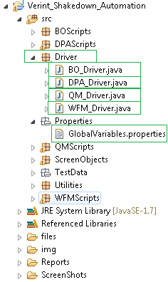

1. click on  Run icon (top left hand side of the page)
2. After completion of execution, open excel file (C:\DEV\VerintAutomation\Verint_Shakedown_Automation\src\TestData\.xls) and click on hyper link of PASS/FAIL then it will open html report.

**----------------------------------------------------------------------------------------------------------------------------------------**

**Steps to Execute System Test Scripts**

1. Copy **DEVSystem** and Software’s folder from Share point and paste it in to C drive of test work station and unzip DEV and Software’s in to C drive.
2. Install eclipse/Spring Tool Suite, Sikuli
3. Make sure that Sikuli files are in “**C:\Softwares\sikuli-install**”
4. Go to “**C:\DEVSystem\Verint\Verint_System_Automation\src\TestData**” and then open excel sheet (i.e. BO_TestData.xls). Update ‘D’ column (column Name: “**Run**”) to **Y** (corresponding to Test case name)
5. Go to “**C:\DEVSystem\Verint\Verint_System_Automation\src \Properties**” folder and then open “**GlobalVariables.properties**” file (open with notepad) and update VerintURL, Admin,DPA Testid, QM CCA, Evaluator,Supervisor,QM Analyst and WFM Forecaster
6. Open Eclipse/STS ( Start🡪eclipse) and then select workspace as “**C:\DEVSystem\Verint**”

Then click on OK button

1. After opening Eclipse/STS, following snapshot will appear

Select and double click on BO_Driver/DPA_Driver/WFM_Driver/QM_Driver module

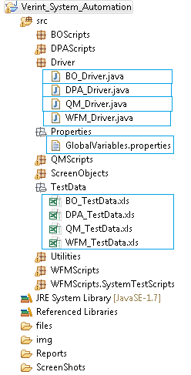

1. click on  Run icon (top left hand side of the page)
2. After completion of execution, open excel file (C:\DEVSystem\Verint\Verint_System_Automation\src\TestData\.xls) and click on hyper link of PASS/FAIL then it will open html report.